Microbiology Department Specimen Container Guide

General Sample Guidelines

If possible, requests should be made using ICE which limits errors in patient identification and speeds up workflow in the laboratory. When making a request please ensure that all the relevant patient identification, clinical details and locations are provided, including the name of the requesting physician.

Contact information must be supplied when an urgent request is made.

A request form must accompany all specimens sent to the laboratory. For high-risk specimens, also attach a yellow Biohazard/Danger of Infection label.

Request Forms
All request forms should clearly state the following information:
• Patient’s surname and forename
• Patient’s address
• Date of birth
• NHS number
• Gender
• Location and Consultant where applicable
• GP practice code where applicable
• Requestor’s name and telephone/bleep number
• Type of sample/specimen
• Date and time sample/specimen taken and who collected it
• Investigations/tests required
• All relevant clinical details including any treatment (recent, current and intended) and foreign travel
• Risk status - if applicable
• Date of onset and duration of illness
• Useful epidemiological information, e.g., date of contact if relevant
• Priority level

The best results are obtained when an appropriate, well taken sample, in the proper container, is delivered to the laboratory promptly and relevant clinical information is provided on the request form.

General sample collection
General guidelines on sample collection are:
• Please fill all sample bottles with the correct volume of required sample.
• Samples must be transported promptly to the laboratory.
• The laboratory does not check the expiry date of sample collection devices when the sample arrives for testing.

It is the responsibility of the person collecting and sending the sample to ensure that the device is in date when the sample is collected and with sufficient time remaining for the sample to reach the laboratory for processing.

Please check expiry dates of specimen container and ensure it is stored as indicated below prior to use.

Please contact the laboratory if there is any doubt about the correct sample to take or concerning the availability of a test.

Minimum Data Set
The Request Form and Specimen must have 4 out of 5 of the following identifiers:

• NHS Number
• Patient’s surname (or coded identifier)
• Patient’s forename
• Date of Birth
• Hospital Number

Please use patient ICE labels if available

Patient Preparation
• Verify the patients’ identity against the laboratory requisition, using a minimum of
four identification details (surname, forename, date of birth and hospital/NHS
number), confirmed with the patient wristband if present and where possible with
the patient themselves verbally.

• Review the clinician’s request and the patient’s written or verbal consent and that
any special requirements have been met.

• Review the procedure with the patient. Inform him or her about the tests for which
the samples are being collected and allow the patient to ask questions.

Please contact the laboratory if there is any doubt about the best sample to take or concerning the availability of a test.

NOTE: All procedures and investigations carried out on a patient need the informed consent of the patient.

Please note that the laboratory infers informed consent has been obtained when samples are received. It is the responsibility of the clinician requesting the test to ensure that informed consent has been obtained.

This consent includes notification to third parties where required by law for example under the Health Protection (Notification) Regulations 2010: we are required to notify any infection of public health significance to local public health department as mandated by the regulation. Please ensure your patient is aware of this before submission of samples for testing.

UKHSA NOTIFIABLE ORGANISMS
We are obliged by law to notify the UK Health Security Agency of food poisoning, TB and Meningitis organisms within 7 days of detection from a clinical sample, so please remember to advise your patient of this both when initially collecting the sample and also remind them when advising them of a positive result. If you require any additional information you can contact the UKHSA at the following:-

UK Health Security Agency
Tel: 020 7654 8000
www.gov.uk/government/organisations/uk-health-security-agency
Twitter: @UKHSA
Facebook: https://m.facebook.com/UKHealthSecurityAgency.

For the full list of notifiable organisms visit: https://assets.publishing.service.gov.uk/government/uploads/system/uploads/attachment_dt a/file/1108438/UKHSA_Laboratory_reporting_guidelines__1_.pdf

Rejection of unacceptable samples
Samples may not be suitable for testing if they are so inadequately labelled that the patient's identification is in doubt, or if they have leaked or been contaminated. If samples are rejected every effort is made to inform the requesting doctor first.

Samples and request forms are checked on receipt to confirm the patient identification (PID) information provided on the form and specimen agree. There is a minimum of 4 PID data items, i.e., Surname, Forename, Date of Birth and ID Number (Hospital or NHS) required by the laboratory and these must match in order for the sample to be accepted. It is good practice for us to have location and date and time of sample but is not absolutely necessary. If errors are found the laboratory will contact the requestor, explain the problem and request a repeat sample.

For samples that are not easily repeated (such as CSF or paediatric samples) the problem will first be discussed with a BMS from the relevant section who will make a decision on whether testing may be allowed to proceed (usually after discussion with the clinician concerned). If the sample is tested the report will clearly state the nature of the problem as a comment. Alternatively, the requesting clinician will be asked to send a repeat sample. For full details regarding incompletely labelled samples or forms please contact the laboratory.

Supply of specimen containers
Please refer to ‘Supply of specimen containers’ tab for details on how to obtain specimen containers.

After sample collection, please refrigerate if there will be a delay in transport to the lab, APART FROM BLOOD CULTURES – THESE MUST BE KEPT AT AMBIENT TEMPERATURE.

Please call 01603 288587 for advice if required.

Urine containers: Microscopy & culture
Mid-stream urine (MSU) and Catheter urine (CSU)
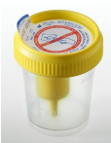
- Yellow top urine collection cup

Please see leaflet: Instructions for collection of microbiology specimens by patients – mid-stream urine for more details

Do not send collection cups for testing – transfer urine into green top monovettes.
Store at ambient temperature before use

- Green lid monovette (9mL) containing boric acid preservative.
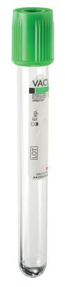
Please ensure that the container is filled appropriately as the correct concentration of boric acid is based on a full sample.

Please do not send urine in boric acid for Mycobacteria investigations but send a plain white universal container.

Do NOT use Lithium Heparin tubes.
Store at ambient temperature before use

Urine containers: Microscopy & culture
Paediatric patients, both MSU and CSU
- Red top 7mL universal container which contains boric acid as a preservative for paediatric patients.

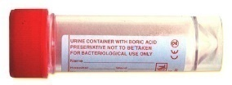
Please ensure that the container is filled appropriately as the correct concentration of boric acid is based on a full sample.
Store at ambient temperature before use

Faecal containers: Bacteriological and virological investigations
- Blue topped 30 ml universal container with a spoon

For faeces samples both bacteriology and virology investigations
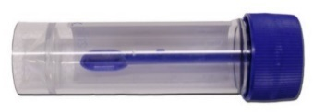
Faeces specimens are NOT processed for Mycobacteria investigations.

Do not contaminate with urine.
For liquid stools do not fill pot more than half full

Store at ambient temperature before use

Sterile universal containers: Microbial investigations
- White topped 30 mL universal container

For e.g.:
- Sputum samples (routine respiratory and Mycobacteria investigations)
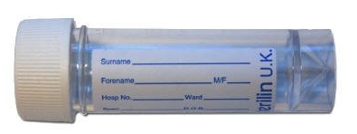
- Bronchoalveolar lavage BAL (routine respiratory, PCP and Mycobacteria investigations)
- Fluids/Aspirates: e.g., Joint fluids, Pleural fluids, CAPD, Ascitic fluids etc.
- Nails for mycology
- Urines (Virology/Mycobacteria investigations)
- Urine for Legionella / Pneumococcal antigen
- Virology investigations
- CSFs
- IUCD
- Tips and lines

Transport without delay to ensure survival of fastidious organisms.
Store at ambient temperature before use

Fungal transport packet: Mycology investigations
- Fungal transport packet for skin and hair samples.
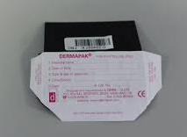
If unavailable collect specimen in preferably dark paper, fold and place in universal container.

Nail samples are preferred in a sterile universal due to larger size of sample.
Store at ambient temperature before use
Bacteriology swab: Bacteriology investigations
- Black topped swab with Amies transport medium with charcoal
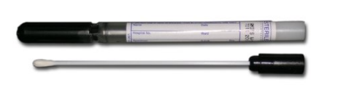
For all bacteriological swab investigations, including MRSA screens from GP and community locations that cannot use the MRSA Broth system.

Cough swabs for respiratory bacteriology including Mycobacteria investigations. However, sputum specimens are preferred.
Store at ambient temperature before use

MRSA Broth – for use in hospital settings only
- MRSA broth in sterile universal - for use in hospital locations only.
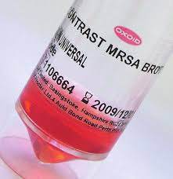
Use with white break-off swab, for MRSA investigations only.

Do not use for virology or other bacteriology investigations.

Store in the fridge before use

Carbapenemase (CPE) screen – for use in hospital settings only
- Red topped Copan double headed swab with gel transport medium.
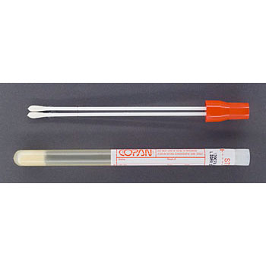
For Carbapenemase (CPE) screening in hospital settings

Do not use for routine investigations.
Store at ambient temperature before use

Bacteriology ENT swab: Bacteriology investigations

- Orange topped ENT fine wire swab with Amies transport medium.
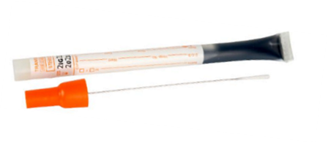
For ear swabs for bacteriological investigations from ENT

Also, can be used for whooping cough (Bordetella pertussis) investigations.
Store at ambient temperature before use

Bacteriology Pernasal swab: Whooping Cough (Pertussis)
- Blue topped fine wire pernasal dry swab
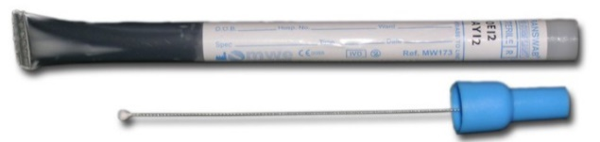
For investigation of whooping cough (Bordetella pertussis)

Store at ambient temperature before use

Blood Culture Bottles
- Blood culture bottles
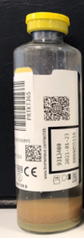
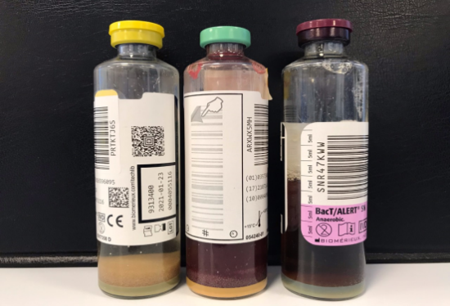
Adult set
1 aerobic bottle (green cap) and 1 anaerobic (purple cap) bottle
8 -10 ml of blood per bottle

Paediatric set
1 paediatric bottle (yellow cap)
Up to 4ml per bottle

Sterile fluids may also be used in these blood culture bottles

Always check use by dates as bottles out of day within 5 days of processing cannot be processed on analyser.
Store at ambient temperature before use

Virology swab: Virology investigations
- Green top liquid viral transport medium (VTM) and a swab
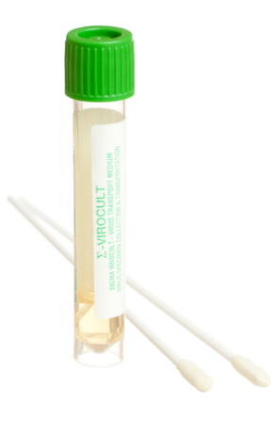
For all virological swab investigations

Do not use for bacteriology or Chlamydia investigations.

Pack contains: Sterile flocked swab, tube with sterile viral transport medium.
Check expiry date on tube before use

Store at ambient temperature before use

POCT investigations: Molecular Transport Medium (LIAT only)
- Inactivating media for use with the LIAT point-of-care testing only
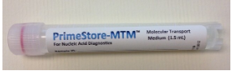
Exact packaging can vary.

Do not use for virology investigations.

MUST NOT COME INTO CONTACT WITH BLEACH – DANGER OF TOXIC GAS
Store at ambient temperature before use

Dry swab: PCR investigations
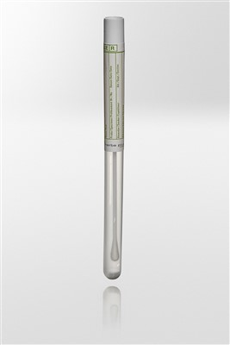
- Dry swab used for some rapid PCR pathways.
Store at ambient temperature before use
Aptima Collection kits:
Chlamydia trachomatis / Neisseria gonorrhoeae and Trichomonas vaginalis PCR
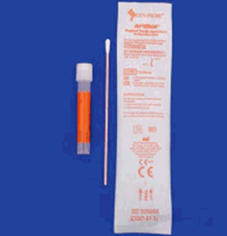
- Aptima Multitest Swab Specimen Collection Kit.
Orange pack containing white topped liquid transport medium and swab.

For vaginal swab, rectal swab, pharynx swab, eye swab, and penile meatal swab specimens for Chlamydia trachomatis/Neisseria gonorrhoeae and Trichomonas vaginalis PCR testing

Break shaft of swab along score line before tightly screwing cap onto tube
Store at ambient temperature before use

- Aptima Urine Specimen Collection Kits for Male and Female Urine Specimens.
Yellow pack containing white topped liquid transport medium and swab.

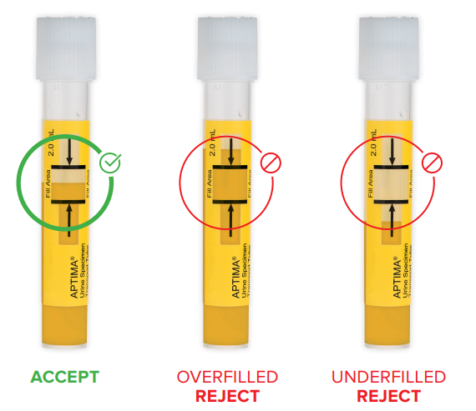
For urine samples for Chlamydia trachomatis/Neisseria gonorrhoeae and Trichomonas vaginalis PCR testing
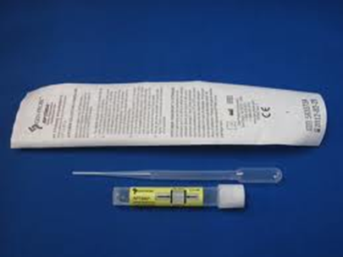

Store at ambient temperature before use

Blood - PCR Requests
- Purple topped blood vacutainer with EDTA.
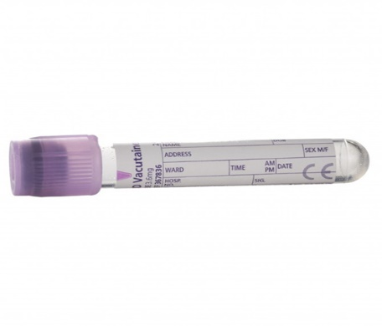
For PCR-based tests such as HIV viral load, hepatitis C viral load and genotyping, hepatitis B DNA, EBV/CMV viral load and meningococcal PCR
Store at ambient temperature before use
Blood – Serum
- Yellow topped blood vacutainer with clot activator and polymer gel (SST)
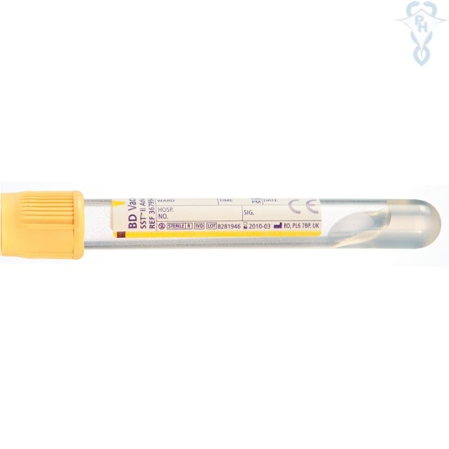
For serology investigations such as HIV, hepatitis screening and Varicella zoster immunity screens.
Store at ambient temperature before use
Antibiotic assays in blood also use this bottle.
Do not use Lithium heparin bottles for serology requests
Blood – Mycobacteria Investigations
- Blue topped blood vacutainer (Sodium citrate) and/or Green topped blood vacutainer (Lithium heparin)
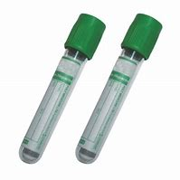
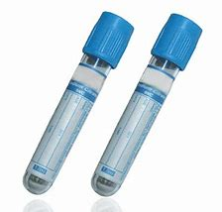

For blood and bone marrow for Mycobacteria investigations.

Do NOT use tubes containing EDTA

Please send up to 20mL of blood
Store at ambient temperature before use

